Abstract—Text summarization plays an important role in interpreting a large amount of text data by extracting only the most important parts of the text. The project aims at exploring the application of Machine Learning techniques in Natural Language Processing (NLP). The project involves creating several models with different combinations of features such as Entity Count, TFIDF, Count Vectorizer and Sentence length. These models are then trained using different SVM kernels and their accuracies are compared. Based on these accuracies, two models were selected for hyperparameter tuning.
Text Summarizer using Machine Learning Models
Kathan Bhavsar, Neel Buddhdev, Twinkle Popat, Rushali Moteria
School of Engineering and Applied Sciences

The project uses an approach where sentences are assigned scores based on the absence and the presence of features and the highest scoring sentences are selected for the summary. The performance of the models are measured using metrics such as ROUGE.

The data set used is CNN Daily Mail News which has 287113 articles. The dataset consists of three columns: unique article id, Original Article, and highlights representing the actual output.

Key words—feature extraction, kernels, named-entity recognition, summarization, SVM, TF-IDF

INTRODUCTION
In today’s world, people can access large amounts of data via the internet. This includes information about health, news, weather, and education. The data can be in the form of numerical data or graphs or text. In the case of large text, it is difficult to interpret the data, thus, text summarization provides a way to extract only the essential part of the text. This technology has become increasingly important in recent years as the amount of information available online has grown exponentially.

Text summarization forms an important part of Natural Language Processing. It aims at shortening the content of a large text data while retaining the essence and the important aspects. Text summarization can be done in two ways, namely the extractive technique and the abstractive technique. The summary generated by extractive technique uses the same sentences from the text, whereas the abstractive technique generates summary based on key concepts of the text [1]. “Extractive technique can be accomplished by applying different techniques such as deep learning, fuzzy logic, Neural Networks (NN), C-means clustering, etc.” [2]. This project uses extractive summarization technique.

Literature Survey
In the paper “Comparative Study of Extractive Text Summarization Techniques” [3], the authors review and compare the performance of three extraction-based summarization techniques: the Conceptual method, Text Rank, and Sentence Scoring. Furthermore, they evaluate summarization quality by comparing individual methods on unsummarized text with their corresponding human-made gold standard summaries paraphrasing.
The authors of the paper “Text Summarization using TF-IDF and Textrank algorithm” [2] propose a system that employs a combination of TFIDF, Text rank algorithm, and NLP techniques to produce summaries of data more effectively than other systems. The system is designed to generate summaries efficiently by utilizing these methods.

The paper “An Overview of Text Summarization Techniques” [4] discusses the process of text summarization and how it involves creating a condensed version of a text while maintaining important information and general meaning. It explains that automatic text summarization is crucial in efficiently finding relevant information in large texts with minimal effort. The paper further categorizes text summarization approaches into extractive and abstractive methods. It presents a comprehensive survey of both approaches in the context of text summarization.

Methodology
The project can be divided into four parts as follows:

Preprocessing the data
This involves sentence tokenization that is breaking the sentence into individual terms. Further stop words and punctuation are removed since they do not add meaning to the summary.

Training a basic SVM model using Named Entity Recognition and Count vectorizer
A count vectorizer matrix and a binary array are created from the articles and are used as input to train a SVM model. Count Vectorizer is method that is used to convert the text into a matrix of counts while NER is used to find entity words to form the binary array.

Training various models using different kernels of SVM
To add more context to the summary, four important features are identified, and five models are formed by different combinations of these features. The features include Entity Count, TD-IDF score, Count Vectorizer and sentence length. The models are trained by using different kernels of SVM and their accuracies are noted.

Hyperparameter tuning of the models
Selecting the two SVM models which give the maximum accuracy. Then the appropriate values of parameters “C” and “gamma” are selected for those models such that the resulting model gives best performance. “C” is the regularization parameter which controls the tradeoff between low training error and low testing error. On the other hand, “gamma” weighs the training samples. Larger value of “gamma” corresponds to lower influence of the training sample and vice-versa.

Impllementation
The implementation of each part is as follows:

Sentence Tokenization
Initially sample articles and their summaries (reference highlights) are appended into two different arrays. Next ‘nltk.sent_tokenize()’ function is used from NLKT library. This function performs sentence tokenization and splits the text into individual sentences.

Count vectorization and NER on text data
From the dataset 500 articles are taken. Count Vectorizer from the scikit-learn library is used. It counts the frequency of the unique words (or features) in each sentence. The value in each cell is the count of the corresponding word in the corresponding sentence. To form the binary array, firstly named entities such as people, organization, location, date, and time are identified from the reference highlights. Then the text data is iterated and “1” is assigned to the sentence if at least one named entity word is present. Then a SVM model is trained with Count Vectorizer matrix as X-train input and the binary array matrix as Y-train input. The result of this model is compared with results of TD-IDF vectorization of the text data.
From the comparison of results, conclusion can be drawn that, the SVM model using named entity recognition can identify important entities and their relations in the text, producing more meaningful results. While the TF-IDF approach only considers the frequency of words in the text, thus, it leads to a summary that has lack of relevance.

Finding accuracies of different models
The following four features are considered:
x1 = Entity Count
x2 = TFIDF
x3 = Count vectorizer
x4 = Sentence length

For each of the above features a function has been defined. The functions are as follows:

count_entity(article, entities): For each sentence it counts the occurrences of entities as mentioned in the set of entities extracted from the reference summary using “filter_entity” function.

TfIdf(article): Calculates the TF-IDF score for each sentence and stores in a list which is returned.

count_vectorizer(article): Counts the occurrences of each word in the sentence and stores it in list which is returned by the function.

sentence_length(article): Counts the number of words in each sentence.

Formation of binary array
Unlike the previous approach to form binary array in Part B of the project, the new approach is an extension of the previous approach. Initially we assigned “1” to the sentence which has entity word and “0” otherwise. In the new approach (represented by function “count_binArray2”) we set a threshold which is equal to total entity words in article divided the total number of words in the article. Then for each sentence a score is calculated.

If the score of the sentence is greater than the threshold then the sentence is assigned “1”, else “0”. This approach takes into consideration the context of each sentence. If the sentence has relatively more entity words than it is important.

Training different models
The following models are created with different feature combinations:
Model-1: Model with x1, x2
Model-2: Model with x1, x3
Model-3: Model with x1, x4
Model-4: Model with x2, x4
Model-5: Model with x3, x4

For each model four different kernels – RBF, sigmoid and polynomial- are trained using 5000 articles. The table below shows the accuracies of the models in different kernels.

Model | RBF | Polynomial | Sigmoid
Model1 (x1, x2) | 0.6267 | 0.6268 | 0.5293
Model2 (x1, x3) | 0.6223 | 0.6301 | 0.5275
Model3 (x1, x4) | 0.6244 | 0.6284 | 0.5399
Model4 (x2, x4) | 0.6290 | 0.6277 | 0.5292
Model5 (x3,x4) | 0.6250 | 0.6267 | 0.5329

Hyperparameter tuning

“GridSearchCV” function is used for hyperparameter tuning technique. The function creates a cross-validation object which partitions the data into training set and validation set. It chooses different combinations of hyperparameters and then fits the model on the training set. For each combination it evaluates the performance and gives the set of best parameters. The search for the hyperparameters has been done by training 1000 sentneces due to computational limitations.

Note: Instead of polynomial models, the top two RBF models have been taken because the polynomial kernel is computationally expensive.

Results
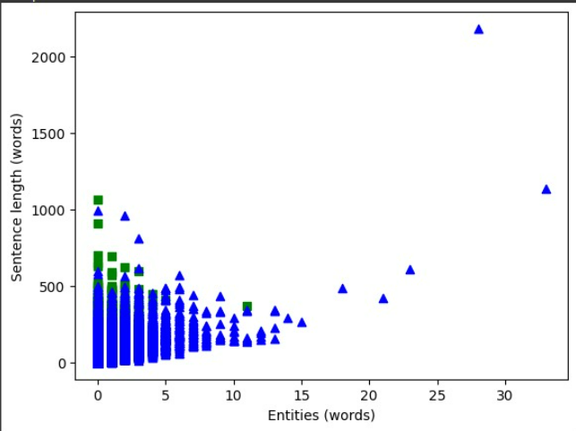
Fig.1. The image above is the graph for the plot of sentence length and entity score for different sentences.

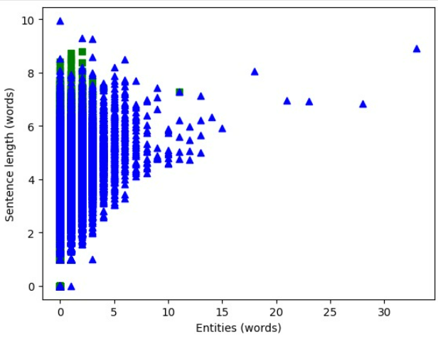
Fig.2. The image above is the graph for the plot of sentence length and count vectorizer score for different sentences.

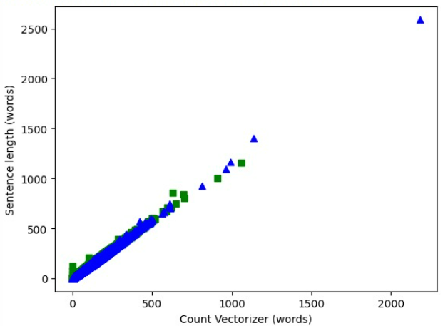
Fig.3. The image above is the graph for the plot of TF-IDF score and count entity score for different sentences.

Report for Model1 RBF: (The original score for Model1 RBF for 1000 sentences is 0.55)
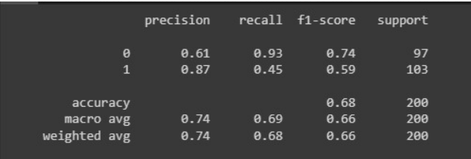
Fig.4. The above image is the output report which has information regarding accuracy, precision, recall and f1-score.

Report for Model2 RBF: (The original score for Model2 RBF for 1000 sentences is 0.55)
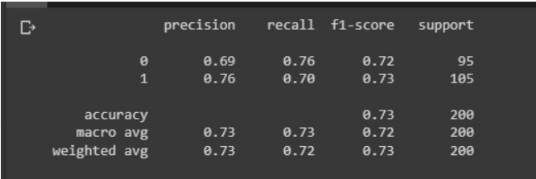
Fig.5. The above image is the output report which has information regarding accuracy, precision, recall and f1-score.

Rouge scores for 901th article:
ROUGE-1 Score: 0.846
ROUGE-2 Score: 0.473

Conclusions
From the results we can conclude that features such as County entity, TF-IDF, sentence length and count vectorizer play an important role in capturing the context of the text data. We explored the use of SVM models using various combinations of these features. Our results show that the use of these features can improve the accuracy of text summarization. The use of SVM with a radial basis function and polynomial kernel yielded the best performance, and hyperparameter tuning further improved the accuracy of the model.
References
- Rahul, S. Adhikari and Monika, "NLP based Machine Learning Approaches for Text Summarization," 2020 Fourth International Conference on Computing Methodologies and Communication (ICCMC), Erode, India, 2020, pp. 535-538, doi: 10.1109/ICCMC48092.2020.ICCMC-00099.
- S. Zaware, D. Patadiya, A. Gaikwad, S. Gulhane and A. Thakare, "Text Summarization using TF-IDF and Textrank algorithm," 2021 5th International Conference on Trends in Electronics and Informatics (ICOEI), Tirunelveli, India, 2021, pp. 1399-1407, doi: 10.1109/ICOEI51242.2021.9453071.
- A. W. Palliyali, M. A. Al-Khalifa, S. Farooq, J. Abinahed, A. Al-Ansari and A. Jaoua, "Comparative Study of Extractive Text Summarization Techniques," 2021 IEEE/ACS 18th International Conference on Computer Systems and Applications (AICCSA), Tangier, Morocco, 2021, pp. 1-6, doi: 10.1109/AICCSA53542.2021.9686867.
- N. Andhale and L. A. Bewoor, "An overview of Text Summarization techniques," 2016 International Conference on Computing Communication Control and automation (ICCUBEA), Pune, India, 2016, pp. 1-7, doi: 10.1109/ICCUBEA.2016.7860024.

